## Financial Ratios

### Liquidity Ratios

$$Current Ratio= \frac{Current Assets}{Current Liabilities}$$

$$Quick Ratio= \frac{Current Assets-Inventory}{Current Liabilities}$$

$$Net Working Capital Turnover= \frac{Net Sales}{Net Working Capital (Current Assets-Current Liabilities)}$$

### Asset Management Ratios

$$Accounts Receivables Turnover= \frac{Net Sales}{Net Acccounts Receivables}$$

$$RMA Inventory Turnover= \frac{Cost of Goods Sold}{Inventory}$$

$$S\&P Industry Surveys Inventory Turnover= \frac{Net Sales}{Inventory}$$

$$Fixed Asset Turnover= \frac{Net Sales}{Net Fixed Assets}$$

$$Total Asset Turnover= \frac{Net Sales}{Total Assets}$$

### Debt Management (Leverage) Ratios

$$RMA Accounts Payables Turnover= \frac{Cost of Goods Sold}{Accounts Payables}$$

$$S\&P Industry Surveys Accounts Payables Turnover= \frac{Net Sales}{Accounts Payables}$$

$$Debt to Total Assets= \frac{Total Debt}{Total Assets}$$

$$Times Interest Earned= \frac{EBIT}{Annual Interest Expense}$$

$$Leverage Multiplier Ratio= \frac{Total Assets}{Common Equity}$$

### Profitability Ratios

$$Net Profit Margin= \frac{Net Income}{Net Sales}$$

$$Net Gross Profit Margin= \frac{Gross Profit (Net Sales-COGS)}{Net Sales}$$

$$Net Operating Profit Margin= \frac{EBIT}{Net Sales}$$

$$Return On Assets \left(ROA\right)= \frac{Net Income}{Total Assets}$$

$$Return on Equity \left(ROE\right)= \frac{Net Income}{Common Equity}$$

### Cash Flow Ratios

$$CF Coverage of Interest Expenses= \frac{CF from Operating+Interest}{Interest}$$

$$Quality of Earnings= \frac{CF from Operating-Preferred Dividends}{Earnings Available for Common Shareholders}$$

### DuPont Analysis

Firms ROE is split into three parts

* Expense Control: Profit Margin
* Asset Utilization: Total Asset Turnover
* Financial Leverage: Leverage Multiplier

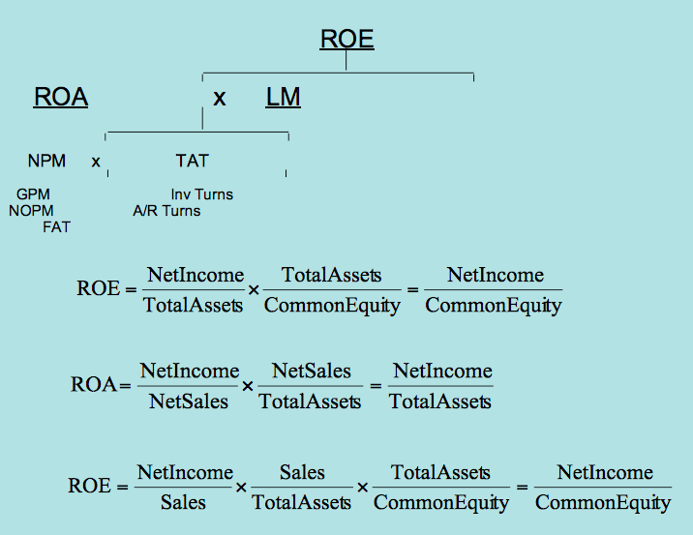

# Time Value of Money

### Equations

$$Fisher Equation=Nominal \left(1+nominal\right)= Real \left(1+real\right)+ Inflation (1+inflation)$$

$$APR=\$1 \left(x\right)[\left(1+\frac{APR}{m}\right)mt]$$

$$EAR=\left[\left(1+\frac{APR}{m}\right)mt\right]=1+EAR$$

$$FVt=PV0\left(x\right)\left(1+r\right)t$$

$$PV0=\frac{FVt}{\left(1+r\right)}t$$

$$Discount Factor=\frac{1}{(1+r)}t$$

### Multiple Cash Flows

$$PV= \begin{matrix}∞ \\ ∑ \\ t=0\end{matrix}\frac{{CF}_{t}}{{(1+r)}^{t}}={CF}_{0}+\frac{{CF}_{1}}{{(1+r)}^{1}}+\frac{{CF}_{2}}{{(1+r)}^{2}}+…$$

### Ordinary Annuities & Annuities Due

$$PV of an Annuity \left(PVA\right)= \begin{matrix}T \\ ∑ \\ t=0\end{matrix}\frac{{CF}_{t}}{{(1+r)}^{t}}=CF+ \frac{CF}{{(1+r)}^{1}}+\frac{CF}{{(1+r)}^{2}}+…$$

$$FV of an Annuity \left(FVA\right)= \begin{matrix}T \\ ∑ \\ t=0\end{matrix}{CF}_{t}{(1+r)}^{t}={CF}_{1}{(1+r)}^{1}+{CF}_{1}{(1+r)}^{2}+…$$

$$PV Factor=[\frac{1-\frac{1}{{\left(1+r\right)}^{T}}}{r}]$$

$$PV of Annuity Due=\left(1+r\right)CF [\frac{1-\frac{1}{{\left(1+r\right)}^{T}}}{r}]$$

$$FV of Annuity Due=\left(1+r\right)CF [\frac{{(1+r)}^{T}-1}{r}]$$

### Perpetuities

$$PV of a Perpetuity= {CF}/r$$

$$r={CF}/{PV}$$

$$CF=PV \left(X\right) r$$

# Interest

$$Nominal Interest Rate=r=r^{*}+IP+DRP+LP+MRP (or RRP)$$

$$r^{*}=Real \left(or pure\right) risk free interest rate$$

$$IP=The inflation premium$$

$$DRP=The default (credit) risk premium$$

$$LP=The liquidity premium$$

$$MRP =Maturity risk premium$$

$$RRP=Reinvestment Risk Premium$$

### Types of Yield Curves

Yield Curve - Moderate rate levels rising continuously with increasing maturity (upward sloping)

Rising Yield Curve - Low rate levels rising substantially with increasing maturity

Inverted Yield Curve - Short-term rates high and declining over entire maturity range

Flat Yield Curve - Rates are relatively constant (invariant) over entire maturity range

# Bonds

### Bond Valuation

Step 1: PV of an Annuity e.g. 20n; 3i; 30PMT; PV = $446.32

Step 2: PV of a Single Sum e.g. 20n; 3i; 1,000FV; PV = $553.68

Use the market interest rate for i

Yield-to-Maturity (YTM) – Discount rate that equates bond price to the PV of all promised cash flows.

APR = Bond equivalent yield. E.g. semi-annual is 2*r, not EAR which would be [1+r/2)]2-1

$$Current Yield=\frac{\$Annual Coupon Payment}{Current Price}$$

Interest Rate Risk (or price risk) – Risk associated with price fluctuations caused by interest rate changes

Reinvestment Rate Risk – Risk associated with the rate at which coupons are reinvested

Default Risk (or credit risk) – Risk associated with issuer’s ability to make payments as specified.

# Stocks

$${PV}_{0}=\frac{Dividend Amount}{{(1+Discount Rate)}^{1}}+\frac{Expected Stock Price}{{(1+Discount Rate)}^{1}}+…$$

$$DDM with Zero Growth= \hat{P_{0}}=\frac{D_{1}}{R}=\frac{EPS}{R}$$

$$DDM with Constant Growth= \hat{P_{0}}=\frac{D_{1}}{(R-g)}$$

$$Expected Rate of Return on Constant Growth Stock=\hat{R}= \frac{D_{1}}{P_{0}}+g$$

$$\frac{D_{1}}{P_{0}}=Expected Dividend Yield$$

G = Expected growth rate

$$Amortized Loan Amount=C \left(x\right)\frac{[(1-({\frac{1}{1+r})}^{n]}}{r}$$

LT bonds are subject to greater interest rate risk.

ST bonds are subject to greater reinvestment risk

Both LT and ST bonds are subject to reinvestment risk on coupons

## Present Value & Future Value

$$FV=\$1 \left(x\right)\left(1+r\right)t$$

$$PV=\frac{\$1}{\left(1+r\right)t}$$

$$Annuity PV=c \left(x\right)\frac{(1-[\frac{1}{\left(1+r\right)t})}{r}$$

$$PV of a Perpetuity=C/r$$

$$Growing Annuity PV=C (x)\frac{(1-[\frac{\left(1+g\right)}{\left(1+r\right)}]t}{(r-g)}$$

$$Growing Perpetuity PV=C \left(x\right)\frac{1}{\left(r-g\right)}=\frac{C}{(r-g)}$$

$$EAR=\left[1+\left(\frac{Quoted Rate}{m}\right)\right]m-1$$

$$Pure Discount Loan PV= \frac{Loan Amount}{\left(1+i\right)n}$$

$$Amortized Loan Amount=C \left(x\right)\frac{[(1-\left(\frac{1}{\left(1+i\right)n}\right)]}{i}$$

$$Current Yield= \frac{Bonds Annual Coupons}{Price}$$

$$Bond Value=C \left(x\right)\frac{ [1-\frac{1}{\left(1+r\right)t}]}{r}+\frac{F}{\left(1+r\right)t}$$

C = Coupon paid each period

r = Rate per period

t = Number of periods

F = Bond’s face value

Cash Flows from Operating Activities

Cash flows from company's primary business activities. E.g. Production and delivery of goods & services for sale. Reflects cash effects of transaction, which are included in the determination of N.I.

Cash Flows from Investing Activities

Cash flows from a company's activities relating to asset acquisition and disposal.

Cash Flows from Financing Activities

Cash flows from a company's activities relating to the receipt and repayment of funds provided by creditors and investors.

## Indirect Method for C.F.

NI Before Dividends

+ non-cash expenses (Depreciation, depletion, amortization)

+ decreases in assets

+ increases in liabilities

- increases in assets

- decreases in liabilities

= C.F. from Operating Activities

Purchase or Sale of Security

$±$ Securities issued or repurchased

$±$ Δ Principal on securities

$±$ Δ in L.T. Asset

= C.F. from Investing Activities

Δ in notes payable (use vs. source of cash)

$±$ Δ L.T. Debt

$±$ Preferred or Common Stock on B/S

+ Dividend Payments

= C.F. from Financing Activities